25AIM:- Develop a system using UML for Online Voting System. Registration of the new citizen and update can be done in the system. The process of initiating the polling. The voting was done from the citizen’s end and the result publishing should be maintained by the admin.

CLASS DIAGRAM:

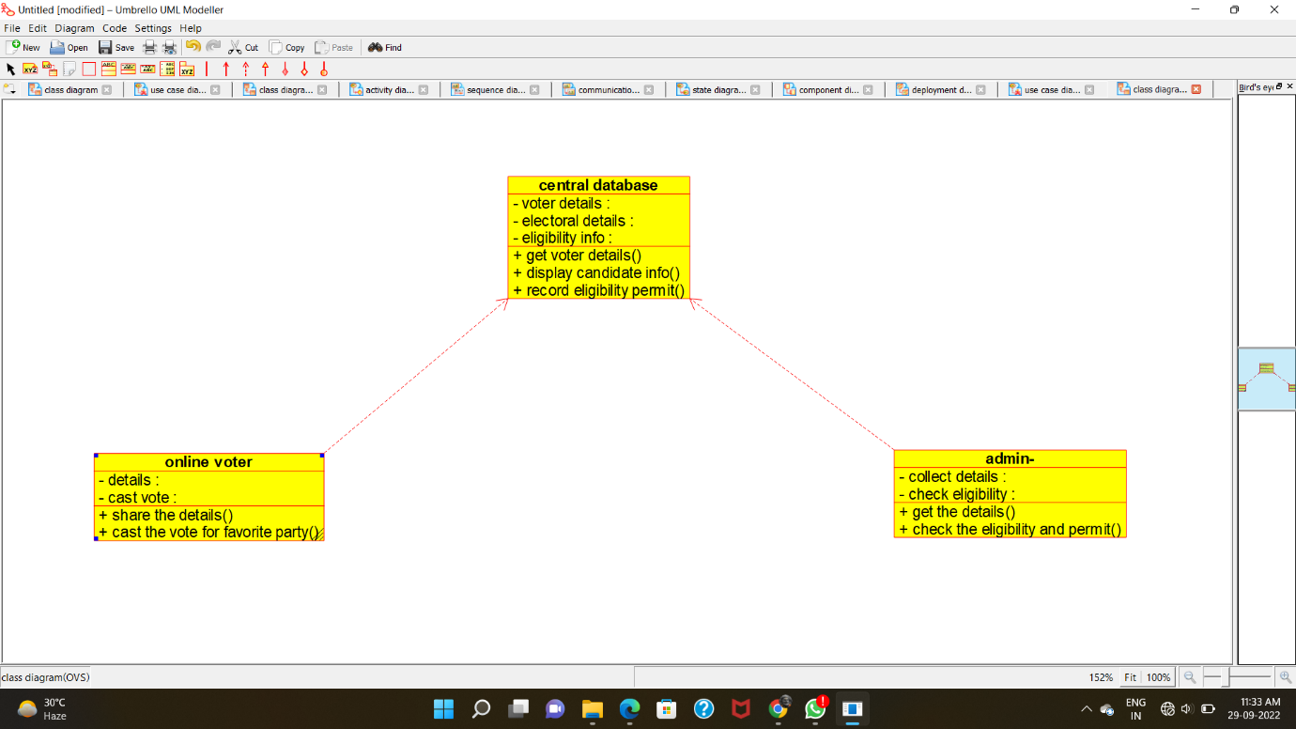

SEQUENCE DIAGRAM: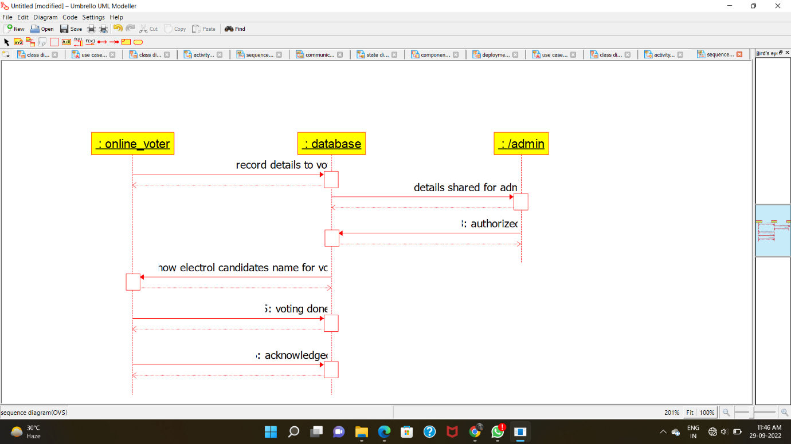

COLLABORATION DIAGRAM:

